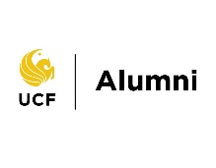
UCF Alumni Career Fair
Sponsorship Package
FY25
$7,500 Knightro Partner
- Reserved sponsorship table.
- Partner logo and link placed on event website.
- Two emails per event with partner logo and link.
- Two social media posts per event with partner logo and tagged handle.
- Partner verbal recognition at event.
- Partner showcased on UCF Knights Network landing page.

$4,000 Black Partner
- Partner logo and link placed on event website.
- One event email with partner logo and link.
- One social media post with partner logo and tagged handle.
- Partner recognition at event.
- Partner showcased on UCF Knights Network landing page.

$2,500 Gold Partner
- Partner recognition at event.
- Partner showcased on UCF Knights Network landing page.

