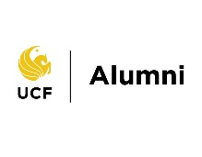
National Networking Knight
Sponsorship Package
FY26
KNIGHTRO LEVEL – $7,500
- Partner logo and link placed on event website and on UCF Knights Network landing page.
- Event emails with partner logo and link.
- One social media post with partner logo and tagged handle.
- Partner verbal recognition at event.
- Five (5) tickets with entry into the event.

GOLD LEVEL – $2,500
- Partner logo on website.
- Partner logo and link included in one event email.
- Partner verbal recognition on stage at event.
- Two (2) tickets with entry into the event.
BLACK LEVEL – $1,500
(Sponsorship available for Headshot Photographer, Bar Station or 360 Photo Booth)
- Partner verbal recognition on stage at event.
- Printed logo on event program or printed material if available
- Partner logo displayed at station.

KNUGGET LEVEL - $500
- Partner logo on website OR one (1) ticket with entry into the event.
- Partner verbal recognition on stage.

